06 April 2023  Private and Confidential |  | Pharmacy Department  Farnham Road Hospital  Guildford  GU2 7LX  T: 01483 443717  E: pharmacy@sabp.nhs.uk

Parent/Carer information
Change from Concerta XL® to Delmosart XL® or Xaggitin XL® or Xenidate XL®

Introduction
The purpose of this leaflet is to explain the change from using a brand of slow release methylphenidate tablets called Concerta XL®, to a different brand named Delmosart XL®, Xaggitin XL® or Xenidate XL®. GPs are also going to be switching some of their patients to one of these brands of methylphenidate tablets. If there are significant shortages of the chosen product, your prescriber may select one of the other brands named in this letter.

What is changing?
Your child has currently been taking the Concerta XL® brand of tablets and is now to be prescribed either Delmosart XL®, Xaggitin XL®, or Xenidate XL®, tablets instead.
Delmosart XL®, Xaggitin XL®, Xenidate XL®, and Concerta XL® tablets all contain methylphenidate which is prescribed for treating Attention Deficit Hyperactivity Disorder (ADHD). These tablets have different brand names as they are made by different companies but they all act in the same way.
The methylphenidate is released slowly from the tablets during the day to ensure the medicine is effective for approximately 12 hours. The beneficial effects of the Delmosart XL®, Xaggitin XL®, or Xenidate XL® tablets will therefore be the same as when your child was taking the Concerta XL® brand.

Why is this change happening?
This change is happening because Delmosart XL®, Xaggitin XL®, or Xenidate XL®, tablets are less expensive than Concerta XL® tablets. By using these tablets, the money freed up can be invested into other NHS services while the treatment of ADHD will be just as good.

What do I have to do?
You do not need to do anything. The medication will continue to be prescribed by your child’s doctor or nurse as before. There will be no change to the way that the prescription is dispensed. The medication is taken at exactly the same time of day as before.

What if I am unhappy with the change?
Please contact your child’s ADHD specialist doctor or nurse to discuss your concerns, they will be happy to discuss them with you.

What do Delmosart XL®, Xaggitin XL®, or Xenidate XL® tablets look like?
All of the different makes of tablets are about the same size – they are about 12mm long and just under 7mm wide.

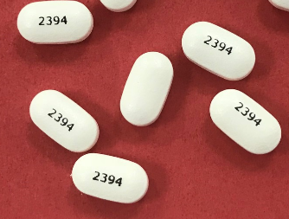

Where can I find more information?
If you have any further questions please ask your child’s ADHD specialist doctor or nurse, or your local pharmacy.

Information about methylphenidate is also available from the www.medicinesforchildren.org.uk website, and from www.choiceandmedication.org/sabp.

